**Expert ID/Name: Nstructive**

**Date: 05-Nov-2020**

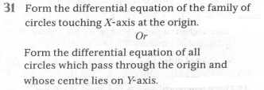

**Answer:**

|  |
| --- |
| Short answer type question |

|  |
| --- |
| Tips:   1. Equation of family of the circles touching the X-axis at the origin or passes through origin whose centres lie on Y-axis is , where is the radius of family of the circles 2. Differentiate with respect to “x” on both sides. 3. If an equation has “n” number of arbitrary constants then we need to do differentiation in “n” number of times. |

|  |  |  |  |  |  |  |  |  |
| --- | --- | --- | --- | --- | --- | --- | --- | --- |
| Given: The equation of all curves,  , Where  are arbitrary constant .  To find\determine\prove: Form the differential equation of  Explanation: -  Step1:   |  |  | | --- | --- | | Instruction | Make the subject is differentiate the differential equation with respect to “ ”. | | Calculation | Differentiate the function  with respect to “x” on both sides. |   Step2:   |  |  | | --- | --- | | Instruction | Substitute  in . | | Calculation | Thus the required differential equation is  . | |
| Verified Answer: -  The differential equation of the function is .  Hence verified. |